

Read Write Inc. Reading Progression Summary
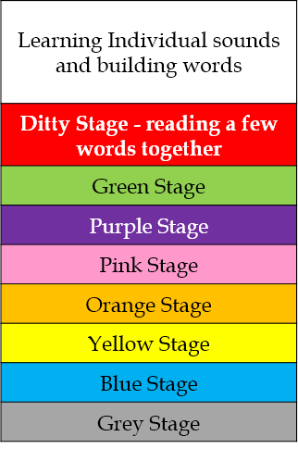
Year 2
- A1- Blue books
- A2- Blue books (comprehension/fluency)
- SP1- Grey books
- SP2- Grey books
- SUM1- Accelerated Reader
- SUM2- Accelerated Reader
Year 1
- A1- Purple books, some S2
- A2- Pink books, all S2
- SP1- Orange books, some S3
- SP2- Yellow books
- SUM1- Yellow books, all S3
- SUM2- Blue books
Reception
- A1- Single letter S1 sounds
- A2- Read all S1 and blend orally
- SP1- Fluent ditties
- SP2- Red books
- SUM1- Green books, some S2
- SUM2- Green/Purple books, S2

